Suffolk County Music Service

Lead organisation of the Suffolk Music Hub

Music for your School 2024-2025

Tuition requirements for the academic year 1 September 2024 to 31 August 2025

School Name: Click or tap here to enter text.
Post Code: Click or tap here to enter text.
Email contact of Music Lead in school: Click or tap here to enter text.
School day starts at: Click or tap here to enter text.
Lunch time and duration: Click or tap here to enter text.
School day finishes at: Click or tap here to enter text.
On which days do you have “before school” provision i.e., breakfast club:
Every weekday: ☐ (or select) Mon: ☐ Tue: ☐ Wed: ☐ Thurs: ☐ Fri: ☐
On which days do you have “after school” provision:
Every weekday: ☐ (or select) Mon: ☐ Tue: ☐ Wed: ☐ Thur: ☐ Fri: ☐

We have frozen our prices for all tuition.
This is the 4th year IVT price has been frozen.

*New for 2024-25*

- WCET ‘Get Ahead’– For those interested in taking part in our pilot programme for WCET, we are trialling a new programme, focussed on empowering groups of students within the class to become class leaders.

The termly programme would be delivered following this schedule:

Week 1 – SCMS tutor works with selected group of students for the full hour
From Week 2 – SCMS tutor works with entire class and uses the ‘Get Ahead’ group to peer support learning. Evidence gathered by delivering this programme previously, has seen marked advancements in learning and engagement from the ‘Get Ahead’ group and the class as a whole.

- Whole Class continuation – those schools wanting to continue whole class tuition for a second year. For schools wishing to change instrument for this second year, this will only be offered as the ‘Get Ahead’ programme.

- Year 7 WCET - We are also now offering mixed instrument WCET to year 7 in schools that are looking to build their instrumental provision. Please discuss options with your named Area Senior Manager.

- CPD programme - We have a wide range of free, online CPD sessions available across the year that we hope your teachers and music leads will be interested in attending. Our programme of events can be found on our website.
If you have any bespoke CPD requirements, please contact us to discuss your needs as we will be very happy to connect you to specific deliverers or organise these on your behalf.

The deadline to return this form is Friday 24th May 2024. Forms received after this may not be processed until the end of the Summer term 2024 and we will not be able to guarantee your requirements or tutor for 2024-25.

Strands of Tuition

Whole Class Ensemble Teaching (WCET)
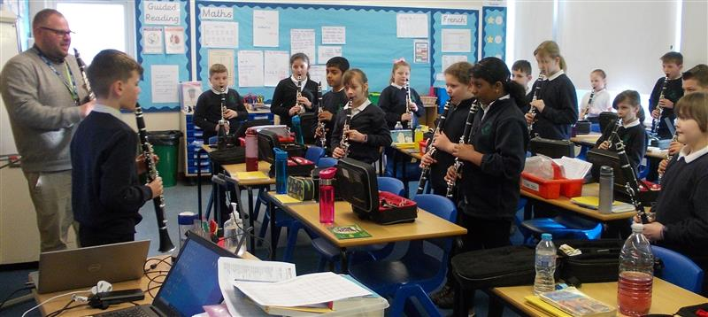
What is WCET?
Whole class music lessons using one instrument from a range of orchestral instruments. Sessions are for 1 hour per class and we guarantee 34 sessions per academic year. This programme is designed for pupils in years 3-5 but can be delivered in earlier year groups, with more age-appropriate instruments. This is for pupils in their first year of learning and free instruments are provided. We ask that the same teacher or teaching assistant must always be present in class, each week.

WCET ‘Get Ahead’– For those interested in taking part in our pilot programme for WCET, we are trialling a new programme focussed on empowering groups of students within the class, to become class leaders.
Whole Class continuation – those schools wanting to continue whole class tuition for a second year. For schools wishing to change instrument for this second year, this will only be offered as the ‘Get Ahead’ programme.
Year 7 WCET - We are also now offering mixed instrument WCET to year 7 in schools that are looking to build their instrumental provision. Please discuss options with your named Area Senior Manager.
WCET
(1 hour per week for a whole class)
Year group | No. Pupils | Preferred Instrument (see list in paragraph 3 for IVT for a selection of instruments) | WCET | WCET ‘Get Ahead’ | Whole Class Continuation
 |  | Click or tap here to enter text. | ☐ | ☐ | ☐
 |  | Click or tap here to enter text. | ☐ | ☐ | ☐
 |  | Click or tap here to enter text. | ☐ | ☐ | ☐
 |  | Click or tap here to enter text. | ☐ | ☐ | ☐
*Please note that 1-hour timeslots can rarely be booked in afternoons, to maximise our tutors’ ability to engage with schools and pupils*.

Annual cost: £1,442 per programme for 1 hour of WCET supplied weekly for 34 weeks across the school year.

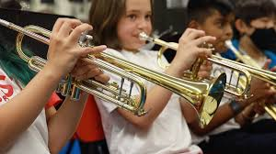
Continuation (CON)

What is Continuation?
Small group lessons to continue pupils’ learning from the WCET programme. Only pupils who have been part of the WCET programme in 2024-25 can access this tuition.
We recommend groups of up to 4 pupils in half hour slots. 34 sessions per academic year

Following an exciting first year for this scheme, we are delighted to be able to offer direct to parent charging to more primary schools for Continuation option 2 provision i.e., the tuition designed to follow on from the WCET year of learning.

For a single charge of £375 to schools (used to cover admin costs and subsidise lesson costs for your students), County Music Service will directly bill parents for 30-minute, small group lessons (maximum 4 pupils in each group). Parents will sign their children up for continuation lessons via the CMS website and Music Service will then ensure that all students, who wish to continue, have a lesson.
Benefits for parents

- Fantastic value for money at effectively £6.50 per 30-minute lesson (this price partly subsidised by the school’s enrolment fee)
- The possibility for your students to use all the skills they have learnt during the WCET year, on a new instrument!!
- Your students will make quick progress on their instrument whilst learning in a small group.
- Parents will have direct connection to the Suffolk Music Hub and all the additional performance and learning opportunities this brings.
- The ability to arrange lessons and instrument hire at the same time from the same organisation.
Benefits for schools
- One single payment for enrolment of £375 per school. Clear for budgeting purposes with no unknowable costs or possible shortfall in recouping costs.
- The amount of continuation time is limitless, so no matter how many students want to continue, one payment enables all of them to be part of the system.
- Your students WCET instrument might not be their ‘perfect partner’ – on negotiation, we could offer some additional instruments for them to try!
- No school office time spent on recouping payments from parents or administering the system & timetabling.
- Parental charges for lessons will be outstanding value at the equivalent of £6.50 per 30-minute lesson per pupil. Parents will pay for their lessons on a termly basis. Instrument hire fees can also be added to these monthly payments.

= | Continuation Cost:  Option 1: Schools can buy continuation time in blocks of 30 minutes for £721 per block. This price guarantees 34 x 30-minute lessons across the school year.  Continuation option 1  (30-minute lessons – small groups of between 2 & 4)  Year group No. Pupils Instrument Initial time required In increments of 30 mins  Click or tap here to enter text. Click or tap here to enter text.  Click or tap here to enter text. Click or tap here to enter text.  Click or tap here to enter text. Click or tap here to enter text.  Click or tap here to enter text. Click or tap here to enter text.  Option 2: Schools can pay a £375 annual cost to enable a direct-to-parent charging plan, run by the County Music Service. This enables as many children as would like to, to continue their learning after the WCET year (even register to try a different instrument – on negotiation), through a termly payment. Please see further de  tails in the ‘New for 2024-25’ section above or for further information, contact your Area Manager.  I would like to express an interest for my school to be part of the direct-to-parent charging plan for Continuation teaching (Option 2) Yes ☐ No ☐

Instrumental & Vocal Tuition (IVT)

What is IVT?

Small group/1:1. We recommend groups no larger than 2 pupils in half hour slots. 34 sessions per academic year

Cost: £714 per 30 mins of teaching, supplied weekly for 34 weeks across the school year.

Instrument Discipline | Year group(s) | No. Pupils | Hours and minutes per week
Upper string violin, viola |  |  | hrs & mins
Lower string cello, double bass |  |  | hrs & mins
Double reed oboe, bassoon |  |  | hrs & mins
Woodwind flute, clarinet, saxophone |  |  | hrs & mins
Brass cornet, trumpet, French horn, euphonium, trombone, tuba, etc. |  |  | hrs & mins
Percussion orchestral percussion, drum kit |  |  | hrs & mins
Guitar - acoustic |  |  | hrs & mins
Guitar – electric |  |  | hrs & mins
Guitar – bass guitar |  |  | hrs & mins
Ukulele |  |  | hrs & mins
Vocal |  |  | hrs & mins
Piano |  |  | hrs & mins
Harp |  |  | hrs & mins

4. All other services and bespoke requests
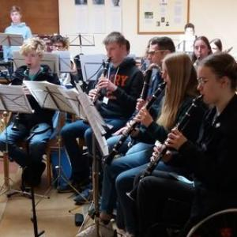
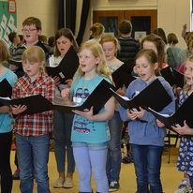

Would you like support with Ensemble directing; Choir Direction; Singing Assemblies; percussion workshop days (Djembe, Samba, Gamelan), Song writing workshops, Music ICT etc.

Ensembles / Music Clubs / Bespoke  Cost: £25.50 per tutor, per 30 mins or £300 for a full school day  Orchestra & band directing & coaching (please give details of what is required).  Click or tap here to enter text.  Click or tap here to enter text.  Click or tap here to enter text. | hrs & mins
Please outline what you would like below. A Senior Manager will contact you to discuss the best options for your school.

We are always available to talk to you but where more thorough input is needed, for example, bid writing, in house CPD, curriculum writing and planning, we charge the following -

Consultancy Services  Cost: £371 per day / £191 per half day  Please give details of what is required or contact us to discuss.  Click or tap here to enter text. | hrs & mins

5. Pricing – please use the table below to work out your costings

A more detailed itemised pricing breakdown is available in the ‘Charges to Schools’ document

Provision Type | Annual Rate  per hour/half hour (please see column 1) / 34 weeks delivery | Order amount  (per week, in hours) | Total cost
WCET  (per 60 mins) | £1,442
Continuation  (per 30 mins) | £721
IVT  (per 30 mins) | £714
Ensembles/Bespoke  (per 30 mins) | *£25.50  (standalone 30 min rate)
 | Totals:
 |  | Number of days | Total cost
Consultancy | £371 full day/£191 half day

6. Timetabling
Please let us know any timetabling information here, in the knowledge that:
Tuition slots of between 1 – 1.5 hours are very likely not to be timetabled in the afternoon due to the fact that they can preclude staff from visiting more than one school and therefore trap unusable time in timetables. That is not always the case however and we consider all situations and requests carefully.

We will do our very best to ensure you are kept up to date with the timetabling process as it develops and hope to have agreed a first draft with you on Monday 17th June 2024

Please enter any timetabling information here: | i.e. Staggered lunchtimes for different year groups; Could you have some tuition before or after school?  Click or tap here to enter text.

7. Declaration
This signed form is a contract for the tuition requested above (subject to availability) for the Academic Year 1 September 2024 to 31 August 2025. I accept the charges for the full academic year 2024-2025 and payment schedule as set out in the Charges to Schools.
Signed (Headteacher) Click or tap here to enter text.
Date Click or tap here to enter text.

Print Name Click or tap here to enter text.

School email address Click or tap here to enter text.

Name of Finance Officer: Click or tap here to enter text.
Email: Click or tap here to enter text.

Please note that returns by email can be dealt with more promptly.
Please return the completed and signed form, by Friday 24th May 2024 to:

Email :county.musicservice@suffolk.gov.uk

Suffolk County Music Service, Northgate Arts Centre, Sidegate Lane West, IPSWICH IP4 3DF

